

Faculty of Media, Science & Technology

MSc Data Science and Artificial Intelligence
August 2026

Optimal Playing Strategy and AI Agents in Ludo

by

Shahir Ali

Faculty of Media, Science & Technology
School of Computing & Engineering
Individual Masters Project

Abstract

Ludo is a widely played stochastic race game that has received little attention in games-AI research compared with chess, Go or backgammon, and the few existing studies report results that have not been independently verified. This study investigates optimal playing strategy in Ludo, asks whether AI agents can outperform rule-based play, and examines which AI paradigms are best suited to a multiplayer game of chance.

A complete Ludo environment was built in Python with a polymorphic strategy interface and a trial framework for running thousands of games while recording win rate, captures made and conceded, and game length. Fourteen playing strategies were implemented: eight rule-based strategies from the literature, an original heuristic modelled on human reasoning, a linear state-evaluation function with weights tuned by Nelder-Mead optimisation and a softmax formulation for the multiplayer case, an expectimax search built on that evaluation, and a neural-network evaluator trained by TD(λ) following the TD-Gammon design. Agents were benchmarked against one another in both two-player and four-player formats.

The published near-100% win rates of simple strategies against random play could not be reproduced; later enhanced-strategy results were, but the reported advantage of TD(λ) over rule-based play was not. Expectimax search over the tuned evaluation function was the strongest agent, winning 63.5% of two-player games against the heuristic at three-ply, whereas no agent exceeded the Enhanced Mixed strategy by more than 2.8 percentage points in four-player play. Analysis of game properties showed that captures occur over three times as often per player in four-player games, and the tuned weights showed the value of a capture falling from 8.5 to 2.6 steps of progress between formats, explaining why aggressive play succeeds in two-player matches and defensive play in four-player ones.

The findings indicate that evaluation-function agents amplified by search are the most effective paradigm for Ludo, that simple rule-based policies remain highly competitive, and that neural reinforcement learning offers no clear advantage in a game with low branching and high dice variance.

Dissertation Declaration

I agree that, should the University wish to retain it for reference purposes, a copy of my dissertation may be held by Bournemouth University normally for a period of 3 academic years. I understand that once the retention period has expired my dissertation will be destroyed.

Confidentiality

I confirm that this dissertation does not contain information of a commercial or confidential nature or include personal information other than that which would normally be in the public domain unless the relevant permissions have been obtained. Any information which identifies a particular individual's religious or political beliefs, information relating to their health, ethnicity, criminal history, or sex life has been anonymised unless permission has been granted for its publication from the person to whom it relates.

Copyright

The copyright for this dissertation remains with me.

Requests for Information

I agree that this dissertation may be made available as the result of a request for information under the Freedom of Information Act.

Signed: .

Name: Shahir Ali

Date: 06/07/2026

Programme: MSc Data Science and Artificial Intelligence

Original Work Declaration

This dissertation and the project that it is based on are my own work, except where stated, in accordance with University regulations.

Signed: .

Name: Shahir Ali

Date: 06/07/2026

Acknowledgments

I would like to acknowledge my family, with whom I’ve played the game which is the subject of this report since I was young. Hopefully now I’ll win more often.

Table of Contents
Abstract iv
Acknowledgments viii
Table of Contents x
Table of Figures xiii
1 INTRODUCTION 1
1.1 Problem definition 1
1.2 Research Questions 2
1.3 Aims and objectives 2
1.3.1 Aims 2
1.3.2 Objectives 2
2 Literature Review 5
2.1 Performance of Symbolic AI in Race Games 5
2.2 Pre-existing Research on Ludo 5
2.2.1 Temporal Difference Learning 6
2.2.2 Q-Learning 6
2.2.3 Overall Results 6
2.2.4 Search-Based Methods 7
2.3 The Research Gap 9
3 Planning and Methodology 11
3.1 Project Methodology 11
3.2 Gantt Chart 11
3.3 Tools and Techniques 11
4 Design and Implementation 13
4.1 Definition of the Task 13
4.2 Class Diagram 13
4.3 Board Representation 14
4.4 Program Notes 15
4.5 Playing Strategies Implemented 15
5 EVALUATION OF ARTEFACT 16
5.1 Fulfilment of Aims 16
5.1.1 Develop a functional Ludo environment in which multiple AI agents can be deployed, play against one another, and have their performance recorded systematically. 16
5.1.2 Investigate the properties of the game of Ludo. 16
5.1.3 Implement multiple agents in the Ludo environment built to play the game autonomously, built using a variety of techniques. 16
5.1.4 Evaluate and compare agents against one another using consistent metrics such as win rate against suitable baselines and against each other, and comparison between two-player and four-player performance. 16
5.2 Fulfilment of Objectives 16
6 Conclusion and Reflection 18
6.1 Answering the Research Questions 18
6.1.1 What are the best playing strategies to use as a person playing Ludo? 18
6.1.2 Can a refined AI agent achieve greater performance in win rate than a playing system based on human logic or simple axioms? 18
6.1.3 Which types of AI playing strategy are the strongest for Ludo? 18
6.2 Improvements 19
6.3 Limitations 19
6.4 Future Work 19
REFERENCES 20
APPENDIX A – Ludo Playing Strategy Results and Analysis (Artefact) 21
7.1 Analysis of Game Properties 21
7.1.1 Theoretical Minimum Moves to Win a Game 21
7.1.2 Average Number of Actions Available per Turn 21
7.1.3 Game Length Distribution 22
7.1.4 Number of Move Options by Game Progress 24
7.1.5 Average Number of Captures Made/Conceded in a Game 25
7.2 Basic Strategies 25
7.3 Mixed Strategy 27
7.4 Enhanced Strategies 28
7.5 Heuristic Strategy 28
7.5.1 Logic Behind Heuristic Ordering 30
7.5.2 Performance Evaluation 30
7.6 State Evaluation Strategy 31
7.6.1 Tuning of Weights 34
7.6.2 Inference of Weight Matrices 34
7.6.3 Comparing Value of Capture Between 2P and 4P 34
7.6.4 Performance Evaluation 35
7.7 Expectimax 35
7.7.1 Search Space Complexity 35
7.7.2 Performance Evaluation 36
7.8 TD(λ) 37
7.8.1 Network Structure and Training Pipeline 37
7.8.2 Performance Evaluation 37
7.9 Overall Results and Conclusions 39
APPENDIX B – Project Proposal 42
Section 1: Project Overview 42
Section 2: Artefact 43
Section 3: Evaluation 43
Section 4: References 44
Section 5: Academic Practice and Ethics 44
Section 6: Proposed Plan (please attach your Gantt chart below) 44
APPENDIX C – Approved Ethics Checklist 45
APPENDIX D – Large File Submission Contents 46

Table of Figures
Figure 1: Image of a Ludo Board 1
Figure 2: The SMART Framework (BiteSize Learning, 2023) 3
Figure 3: Noughts and Crosses Example Minimax Tree (Nested Software) 8
Figure 4: 2-ply Ludo Expectimax Structure Diagram 9
Figure 5: Project Gantt Chart 11
Figure 6: Ludo Program Class Diagram 14
Figure 7: Average Legal Moves per Turn in a 2-Player Match 21
Figure 8: Average Legal Moves per Turn in a 4-Player Match 22
Figure 9: Game Length Distribution Kernel Density Estimate Graph (4 Players) 23
Figure 10: Game Length Distribution Kernel Density Estimate Graph (2 Players) 23
Figure 11: Average Number of Legal Moves by Game Progress - 2 Players 24
Figure 12: Average Number of Legal Moves by Game Progress - 4 Players 24
Figure 13: Average Captures Made/Conceded by Number of Players 25
Figure 14: Basic Strategies vs 3 Random Opponents (Win Rate %) 25
Figure 15: Performance Statistics of Basic Enhanced Strategies (Alhajry et al., 2012) 26
Figure 16: Basic Strategies 4-Way Match (Win Rate %) 26
Figure 17: Basic Strategies 4-Way Match - Full Trial Metrics 27
Figure 18: Mixed Strategy - 4-Way Match Vs Basic Strategies (Win Rate %) 28
Figure 19: Enhanced Strategies 4-Way Match (Win Rate %) 28
Figure 20: 2 Enhanced Fast, Enhanced Defensive, Enhanced Aggressive (Win Rate %) 28
Figure 21: HeuristicStrategy Code Snippet 29
Figure 22: Heuristic vs Basic Strategies – 4-Player Match (Win Rate %) 30
Figure 23: Heuristic vs Enhanced Strategies – 4-Player Match (Win Rate %) 30
Figure 24: Heuristic vs Enhanced Mixed - 4 Player Match 31
Figure 25: Heuristic vs Enhanced Mixed - 2 Player Match 31
Figure 26: State Eval Strategy Pseudocode 31
Figure 27: Weight Matrices and Player Score Calculation Code Snippet 32
Figure 28: Evaluation Functions Code Snippet 33
Figure 29: State Evaluation vs Heuristic - 2-Player Match Results 35
Figure 30: State Evaluation vs Enhanced Mixed - 4-Player Match Results 35
Figure 31: Expectimax vs State Evaluation – 2-Player Match Results 36
Figure 32: Expectimax vs State Evaluation - 4-Player Match Results 36
Figure 33: Expectimax vs Heuristic - 2-Player Match Results 36
Figure 34: Expectimax vs Enhanced Mixed - 4-Player Match Results 36
Figure 35: 3-Ply Expectimax vs Heuristic - 2-Player Match Results 36
Figure 36: Captures Made/Conceded versus Heuristic by Depth of Search 37
Figure 37: TD(λ) vs Heuristic - 2-Player Match Results 38
Figure 38: TD(λ) vs Enhanced Mixed - 4-Player Match Results 38
Figure 39: TD(λ) vs State Evaluation - 2-Player Match Results 38
Figure 40: TD(λ) vs State Evaluation - 4-Player Match Results 38
Figure 41: TD Training Snapshot 1 38
Figure 42: TD Training Snapshot 2 39
Figure 43: All Strategies vs 3 Randoms - Win Rate (%) 40
Figure 44: All Strategies vs 1 Random - Win Rate (%) 40
Figure 45: All Strategies vs 3 Enhanced Mixed - Win Rate (%) 40
Figure 46: All Strategies vs 1 Heuristic - Win Rate (%) 41

INTRODUCTION

Problem definition
Ludo is a classic race game (a game played by moving pieces around a track to a finish line by way of dice rolls) played on a cross shaped board, with predecessors of the modern game having origins in ancient India (Lal, 1952). The game is played around the world and known by many different names, such as Pachisi in the USA and much of Europe. The research surrounding the game is limited compared to other classic board games, such as Chess and Go. In general, reinforcement learning has been shown to be effective in non-deterministic games, such as in backgammon, where Tesauro (1992) built a system based on temporal difference learning called TD-Gammon which was able to outperform human built expert systems. There has been some research done on Ludo in academic papers, such as by Alvi & Ahmed (2011) who compared different heuristic based players and Alhajry et al (2012) who built further on this study and implemented intelligent players trained using temporal difference and Q learning. However, the amount of research on this game is limited compared to others, providing a valid research gap for this study.
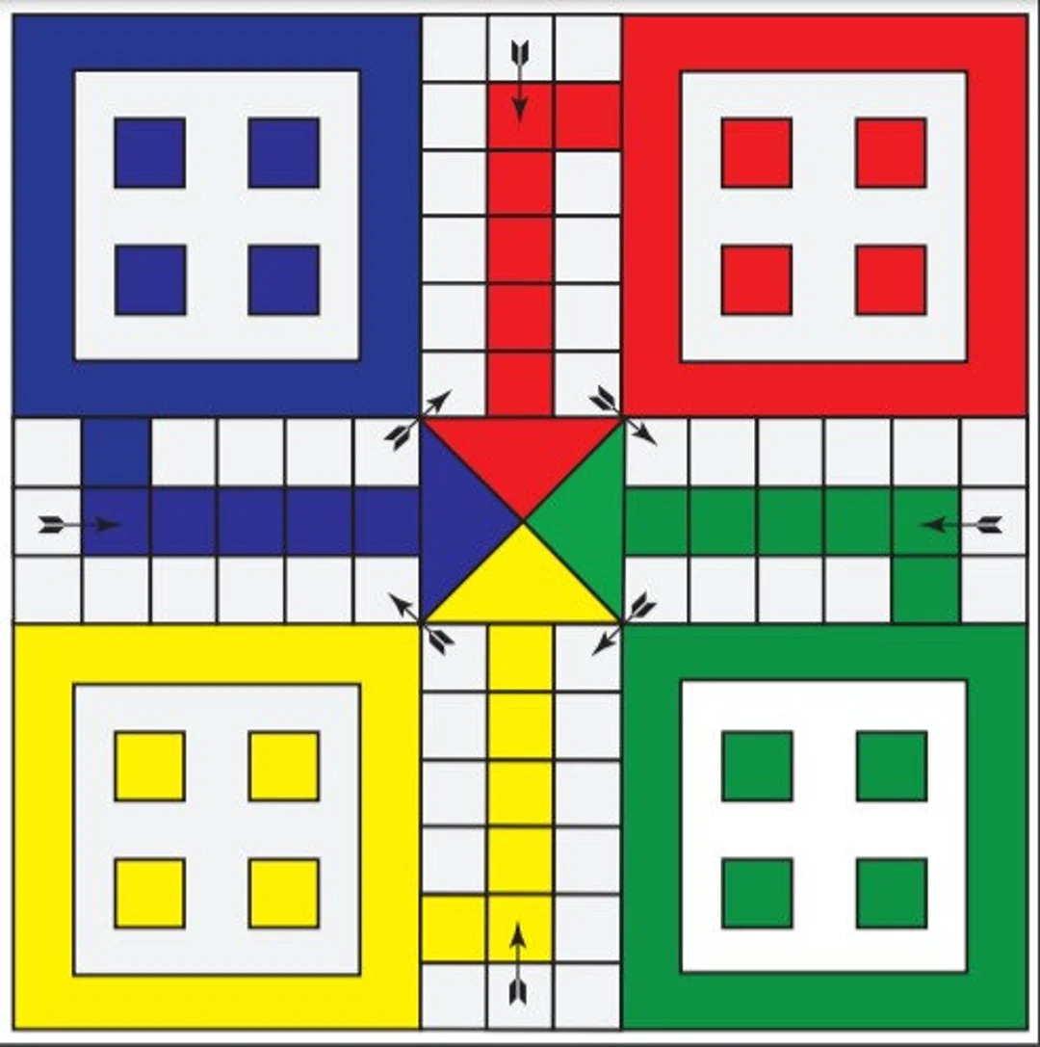
Figure 1: Image of a Ludo Board
The study will aim to study and explain what the optimal core strategies are for the playing of Ludo through both learning the properties of the game, as well as testing different strategies against each other, including attempting to recreate the results of past studies in this field. It will also aim to create AI agents capable of beating an expert system using methods such as reinforcement learning and game-tree search.

Research Questions

What are the best playing strategies to use as a person playing Ludo?

Can a refined AI agent achieve greater performance in win rate than a playing system based on human logic or simple axioms?

Which types of AI playing strategy are the strongest for Ludo?

Aims and objectives

Aims

- Develop a functional Ludo environment in which multiple AI agents can be deployed, play against one another, and have their performance recorded systematically.
- Investigate the properties of the game of Ludo.
- Implement multiple agents in the Ludo environment built to play the game autonomously, built using a variety of techniques.
- Evaluate and compare agents against one another using consistent metrics such as win rate against suitable baselines and against each other, and comparison between two-player and four-player performance.
- Critically analyse the strengths, limitations, and suitability of each AI paradigm for a stochastic, multiplayer game environment such as Ludo.

Objectives
The project objectives will be written using the SMART targets framework to describe them, as shown in the image below.

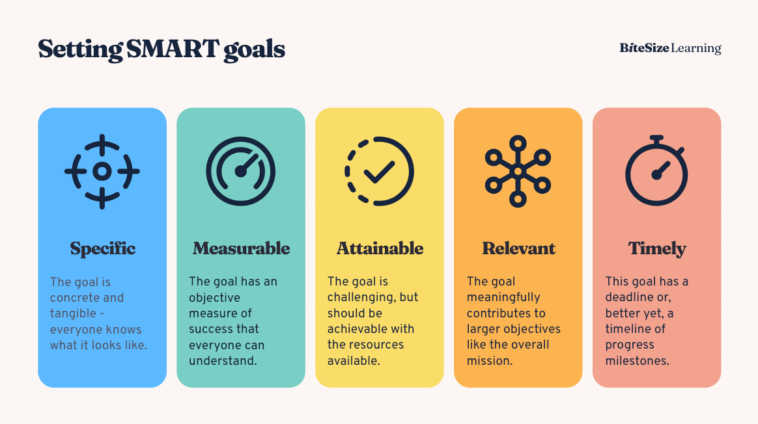
Figure 2: The SMART Framework (BiteSize Learning, 2023)

Objective 1: Develop a Ludo simulation environment
S | Develop a complete, end-to-end simulation environment in Python for the board game Ludo where an AI agent can play autonomously
M | Following the game logic of Ludo perfectly and verifiably using logs and visualisations
A | Using Google Colab as a development environment and utilising pre-existing libraries.
R | In order to provide a setting for deployment, evaluation and training of AI agents.
T | Aiming to complete this by the end of June.

Objective 2: Implement basic strategy players and AI agents to play in the game environment
S | Implement the basic and enhanced strategies discussed by Alvi & Ahmed (2011) & Alhajry et al (2012), a custom heuristic strategy and “smart” players trained using machine learning methods
M | Implement all 8 rule-based strategies from literature and at least 3 original, sophisticated playing strategies.
A | Base the AI agents on studied techniques of games AI design, such as expectimax search and temporal difference learning.
R | In order to test them by playing them against each other so as to evaluate their performance.
T | Aiming to complete this by the end of July.

Objective 3: Evaluate playing strategies and AI Agents
S | Compare the performance of basic strategies and AI agents against each other, using original strategies, methods from existing literature and random play as baselines where appropriate.
M | Using metrics such as win rate, number of captures, number of captures conceded, moves taken to victory, etc
A | Using previous literature and win-rate performance as a basis for comparison
R | In order to answer the research questions of what the best strategies are to use as a person playing Ludo, and whether a trained AI agent can consistently beat a rule-based playing system.
T | Aiming to complete this by the end of August.

Literature Review

Performance of Symbolic AI in Race Games
Symbolic AI is AI which operates in a way that is based on distinct, human interpretable and explainable rules. These are also known as expert systems. Such systems are relatively simple in their architecture and have no learning capabilities. Their effectiveness comes down entirely to the knowledge built into them by their designers. As such, they require great domain knowledge to be effective, and effective they can be.

There is an example of a purely rule-based program utilising no forward searching beating a world champion at the game of backgammon, by BKG 9.8 (Berliner, 1980). Backgammon is undoubtedly a different and more complex game than Ludo, however there are similarities between them that allow findings from one to be transferrable to the other. Both games have pieces which move in one direction round a board using dice rolls, and which can attack and be attacked to send a piece back to the start, and there is a greater body of work on backgammon than ludo to draw from.

This program was built by computer scientist Hans Berliner, who had been a top 12 chess player in the USA and had previously won the world correspondence chess championship in 1968. It was also built with the help of Paul Magriel, a former world champion. On the day following the victory of the 1979 World Backgammon Championship, where Paul Magriel had lost his title to Luigi Villa, the newly crowned world champion lost seven matches to one to BKG 9.8.

BKG 9.8 worked using a simple architecture of V = A₁F₁ + A₂F₂ + … + AₙFₙ where A is a weight, F is a complex feature such as how many pieces can attack a specific piece, or which location on the board is the most strongly blocked, and V is a score given to a piece. During development however, Berliner found that using static weights was not very effective, as this can only encode information on the average of a feature’s value across the game, not considering how that evolves across game stages (midgame versus endgame). So BKG uses application coefficients, which are weights that evolve as the game goes on in a continuous manner to reflect the changing game stage. This system uses no search or lookahead beyond the result of the next move; backgammon has a branching factor of up to 400 at each move, making search based methods less feasible, and the creator wanted a challenge of designing a system based on pure evaluation.

Pre-existing Research on Ludo

The literature in regards to Ludo is sparse, however two papers (Alvi & Ahmed, 2011; Alhajry et al, 2012) show that a mixed strategy player, utilizing simple priority rules (escaping capture > making a capture > moving the furthest piece > moving any piece) can beat its simpler component strategies 91% of the time and a player making random moves 100% of the time. Alhajry et al (2012) builds on this study by implementing enhanced versions of these strategies that prioritise piece activations, as well as two strategies trained by TD(λ) and Q-learning respectively, with the former being a value function (makes a judgement on the state of the game as to the strength of each player’s position) and the latter being a policy function (learns a policy according to which the strategy can choose advantageous moves).

The two aforementioned strategies fall under the bracket of reinforcement learning. Reinforcement learning is a machine learning technique where instead of a model receiving a signal at the end of a training epoch based on where it went wrong as in classical supervised learning AI, the model learns by performing a task and receiving reward or punishment based on its performance. This allows an AI to learn a policy or evaluation function on its own without direct instruction

In both reinforcement learning setups the state representation is done using arrays of length 59, matching the total number of positions on a Ludo board representation (52 squares on the board, 5 on the shared home track, the initial yard and the home area). Each index of the array corresponds with a position on the board, with the values corresponding to the number of pieces that one player has in that position.

Temporal Difference Learning

The core idea of temporal difference learning is that following each move, the value function is updated so that the estimated value of past moves more closely matches the current value estimate. This is based on the idea that later value estimates are closer to the conclusion of the game where the terminal reward (for win/loss) is given, which acts as a point of ground truth in the game sequence (Sutton, 1988). Across many training games, the reward signals from the terminal reward propagate backwards towards earlier states.

The temporal difference learning setup in this paper is based loosely on the structure of TD-Gammon (Tesauro, 1994), an AI playing agent for backgammon trained using a type of temporal difference learning called TD(λ) that was able to compete with grandmasters.

In vanilla temporal difference learning, known as TD(0), the value function is updated using only the directly preceding state’s value estimate. TD-Gammon, however, uses TD(λ), which updates multiple preceding states in a single step, weighting the update based on how recently the state was visited according to the decay parameter, λ.

In the case of this implementation and in following with TD-Gammon, the evaluation function is a neural network taking the four previously mentioned arrays as inputs and outputting four values corresponding to win probabilities for each player.

The results of this study showed that a single TD-Player versus three Enhanced Mixed Players has a win-rate of up to 30%.

Q-Learning
Traditional Q-Learning stores pairs of states and actions with a score. At the beginning of training, all scores are initialised randomly or to zero. The model learns by increasing the score of a state-action pair based on the reward earned from following it as well as the highest available score from the following state.

Given that the possible number of states in Ludo is 10²² (Alhajry et al, 2012), it becomes unfeasible to use a traditional Q-table. The study instead uses a neural network to estimate the Q function. The set of actions corresponds not to pieces but to the previously mentioned basic strategies (Defensive, Aggressive, Fast and Random, as well as Release for activating a piece). This learning setup used intermediate rewards in addition to the terminal reward for winning or losing the game, for actions such as activating a piece or capturing an opponent’s piece.

Overall Results

This strategy achieved a win-rate of 27% against three Enhanced Mixed players, slightly worse than the TD-Player. Testing two TD-Players against two QL-Players showed the TD-Player as achieving a 27.37% win rate and the QL-Player as achieving a 22.37% win rate, demonstrating the TD(λ) player as being superior.

This is likely due to bias introduced by the arbitrarily selected intermediate reward values used for Q-Learning, which the paper also concludes. The paper also reflects that though both reinforcement learning trained players beat the Enhanced Mixed strategy baseline, neither showed a significant improvement, showing the simply derived, rule-based strategy as being very formidable, as well as the difficulty to be found in gaining a meaningful advantage through strategy in a game based on chance.

An explanation for the lesser performance of RL learning seen in Ludo compared to other games could be that Ludo generally has very few legal moves available at each turn. For example, chess has an average of 35 moves available at each turn (Allis, 1994) and backgammon has 20 given a known dice roll (Tesauro & Galperin, 1996). This is contrasted with only a maximum of 4 possible moves at a given turn in Ludo, with many turns having only one or none, which may not allow enough space for a reinforcement learning player to learn much or show distinction compared to a simpler player.

Search-Based Methods
The game tree refers to the representation of interconnected game states as a hierarchical graph structure. Search based methods work by traversing the game tree forwards and evaluating potential future moves/states.

Examples of searching future game states in board game AI include the checkers AI, Chinook, which searches a minimum of 19 moves ahead on average (Schaeffer, 1994) and defeated Marion Tinsley, widely considered to be the greatest checkers player who ever lived (Thomas, 1995), as well as IBM’s famous Deep Blue chess machine, which could evaluate 200 million chess positions per second (IBM, 2024).

An important consideration in such a playing strategy is the searching algorithm, which governs both how the game tree is traversed, as well as how the information is passed back up to inform the next move. A search based AI strategy for Ludo must consider the effects of chance in the game, and must therefore work in the realm of probabilities, considering not just what game states would be favourable, but the likelihood of a favourable game state occurring given different dice rolls.

Minimax
An archetypical technique in search based game playing methods is minimax (von Neumann, 1928). This is a search method for zero sum games that aims to make the best decision by maximising your evaluation score (a numerical representation of how favourable a board is for you), and assuming that your opponent will make the move that minimizes your evaluation score. From the current state, the algorithm plays out positions to completion of the game, or to a specified depth (for example, giving all resultant states reachable in 3 moves), and arranges them in a hierarchical tree structure, where each node is a maximising node, playing to maximise the player’s evaluation score, or a minimising node playing to minimise it. Here is an example given from noughts and crosses.

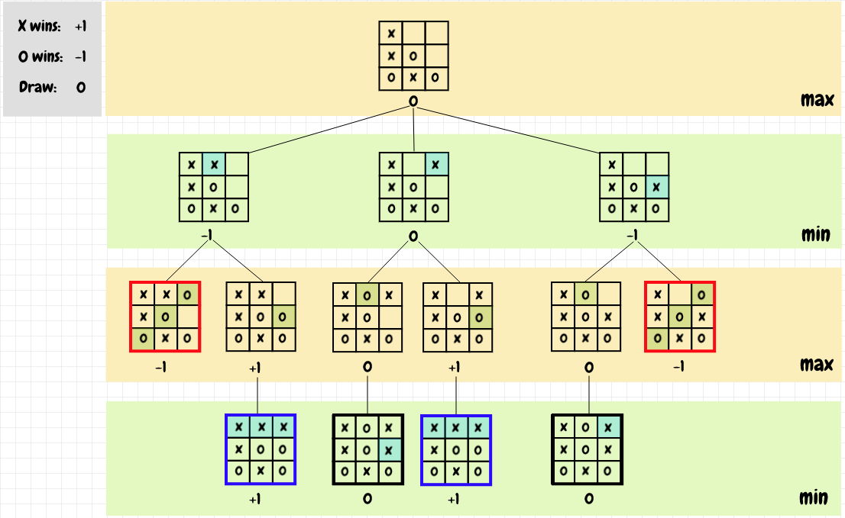
Figure 3: Noughts and Crosses Example Minimax Tree (Nested Software)
The terminal game states and scores are given in this example as the leaf nodes, with a score of +1 given for a win to X, -1 for a win for O (our opponent) and 0 for a draw. Starting from the penultimate layer and going up each layer towards the root, each node’s value takes either the maximum or the minimum value of all its children; this alternation captures the effect of an opponent trying to actively hinder you on their turns. The root node’s value at the end of the algorithm shows what the player-to-move’s best state could be playing to the depth of the search given optimal play from both sides, and the path that value took from leaf to root shows which move to pick next.

The problem minimax solves is that as can be seen in the above tree, winning positions for X are theoretically reachable, however trying to play positions towards that game state would likely lead to a loss as your opponent would certainly intercede. So minimax gives the path of optimal play in consideration of that, leading to a draw in this instance.

However, this setup does not work for Ludo. There is nothing in minimax that considers the element of chance, and that a player may not be able to select what path they can choose at their turn. What is needed here is an additional type of node, which can resolve the issue of random chance by evaluating all optimal states resultant from different dice rolls and averaging them. The addition of this feature to minimax is often called as expectimax.

Expectimax
The addition of the chance node to game tree search was first described by Donald Michie (1966). Given below is a tree diagram (not the game tree) showing how a 2-ply expectimax search would function in Ludo.

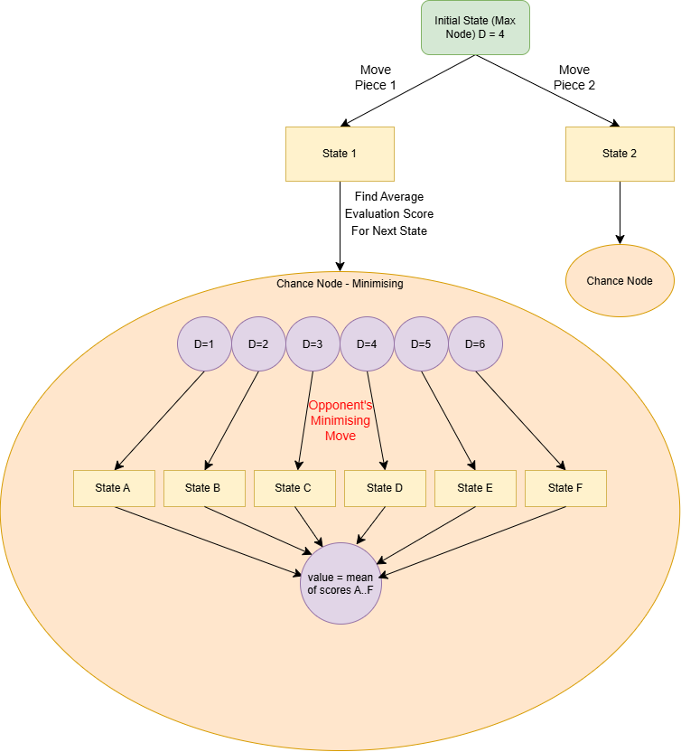
Figure 4: 2-ply Ludo Expectimax Structure Diagram

For each legal move available to the player (two in this case) the algorithm takes the resultant state and evaluates the score following an optimal move from the opponent for each possible dice roll they may get. These scores are averaged and passed up to the parent node.

Adding another layer of depth would involve adding another 6 chance nodes as children of this chance node, considering the maximising move from each dice roll.

The Research Gap

Having reviewed the research on Ludo, with a focus on varying types of game playing AI, some clear gaps can be seen which my project could explore. Firstly, there is no search-based AI player for Ludo implemented in any existing literature, so creating one for this project would be an innovative step in research. Secondly, the heuristic based players seen in previous research are quite simplistic, and don’t reflect what would be the logical thought process that a human player would consider in selecting a move. As a result, the baseline that these studies are comparing their AI players may be setting a low bar that oversells their playing performance.

This project aims to fulfil both of these objectives in creating a novel search-based AI player using an original evaluation function, and a more advanced heuristic player. In addition, it will test methods such as the simple/mixed strategy players shown by Alvi & Ahmed, and the TD player implemented by Alhajry et al.

Planning and Methodology

Project Methodology
My project has defined requirements, a bounded timeframe, a small team (just me) and a familiar domain. Therefore, the best choice for this project would be a Waterfall methodology where each segment of the project is completed in step, as this is best suited to a small, bounded project with a single developer, since with this being a graded piece of work, it is necessary that each criterion which will be graded gets the required time allotted to it, and that all of these steps are completed before the due date.

A shortfall of Waterfall is that development and testing are started quite late, however since the technologies being used (Python, Jupyter, NumPy, etc.) are well known to me, this is not such an issue. A benefit of Waterfall is that since development time is limited, it reduces the likelihood of scope creep, which could eat into time that could have been better spent on writing of the report.

Gantt Chart

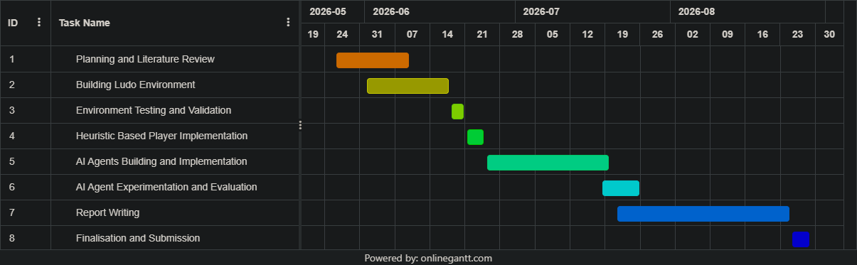
Figure 5: Project Gantt Chart

Tools and Techniques

Python: The language that will be used for all the programming in this project. It is the de facto language for research in data science and artificial intelligence, and has a number of libraries which will help in this project.

Pandas/NumPy: These are widely used libraries for data storage and manipulation. Pandas offers the powerful DataFrame data structure and integrates with NumPy which can be used to perform various statistical analysis operations.

Matplotlib/Seaborn: These libraries will be used for creating graphs and visualisations displaying the results of the project.

Google Colab: Colab has been chosen as the IDE as this project lends itself well to being done in a Jupyter Notebook, where code can be organised in a modular fashion as a sort of document, differing from a traditional wall of text or jumble of directories. Colab is my choice of Jupyter environment because of its cloud save and cloud execution features, which can provide a higher level of compute compared to a personal device.

Object Oriented Programming (OOP): As this is a setting modelling a complex real world system with clear ownership relationships (the game owns the player who owns the pieces), OOP, which structures code around objects, each having attributes and methods based on their class, is a natural choice.

Design and Implementation

Definition of the Task
Ludo is a casually played board game and has no fixed ruleset. However, the following rules are common within most variants of the game:

- Each player has 4 pieces that start in a home base.
- The objective of the game is to complete a circuit of the board with all 4 pieces.
- Each player rolls the dice on their turn in order to either move their piece that number of spaces or move their piece from their home base onto the track.
- A player must roll a 6 in order to move a piece from the home base onto the main track
- Rolling a 6 affords the current player an extra turn
- Landing on an opponent’s piece on a standard square performs a capture, wherein that piece is sent back to the home base.
- Safe squares are present on the board where no piece can be captured in places such as the first square a piece lands on when it is activated. These are safe for all pieces and multiple pieces can sit on them.
- After circuiting the main track, a piece enters the home track where only their pieces can enter.
- In order to complete a piece, the dice roll that enters the end zone must be an exact amount, not more than is required.

Rules such as blockades (safe spaces formed by stacking multiple of your pieces on a square) or losing all your previous turns if you roll three sixes in a row will not be considered for the purposes of this study.

Class Diagram

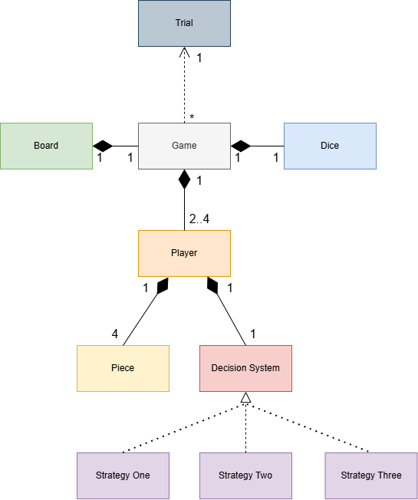
Figure 6: Ludo Program Class Diagram
Figure 4 is a UML class diagram showing the proposed structure of the program which will provide a playing environment for the game, a way of easily implementing and swapping different playing strategies for a player, and a way of running many games together to work out average metrics for different playing strategies such as win rate.

The Game class is the entity which contains all structures related to an individual game (Board, Dice, Players). The playing strategies exist as attributes of the Player class where they are implemented as inheriting the abstract class Decision System, with the abstract method make_decision. This structure provides a consistent method of implementation for all playing strategies. The Trial class runs a specified number of games in a row with players using the same Decision System in each game. This is required as Ludo is a game of chance, and not much can be learned from any single game.

Board Representation

Each Piece object has an attribute of position with an index between -1 and 58, with indices having the corresponding to the following board positions:

- -1 is the home base for all pieces. No capture or movement can occur here so all these pieces can share the same index
- 58 is the end zone for all pieces.
- Indices 0 to 52 represent the main track of the board, where pieces can move around. Because different pieces have different paths round the board based on where their owner Player starts off, the movement logic is determined by the parent’s start point to ensure each piece follows the correct path.
- Indices 53 to 57 represent the home track. As no captures can occur here, all players can share the same indices for a simpler game representation.
- Indices 0, 13, 26 and 39 represent the possible starting positions for a player. These are all safe squares.

This logic is all contained within the Board class.

Program Notes

- The Piece class contains all the methods which check or alter properties of a piece (checking safety, activation, whether a piece has a capture available)
- The Player class contains analytical data on the player, such as how many times they’ve captured and been captured, as well as the DecisionSystem inheriting object which is used in the method Player.make_decision to pick a move, with the behaviour of this method depending on what class is used here. This implements a paradigm of OOP called polymorphism.
- DecisionSystem is a Python Abstract Base Class (ABC); this is a type of class which doesn’t have objects made of it, but instead exists only as a structural template for what methods and attributes a class inheriting from it must implement.
- Game acts as the container for all objects within a game, and controls all aspects of game flow, such as piece movement, and which player’s turn it is.
- Moves exist and are passed between methods/objects as a structured tuple, in the format {piece, action}, where action can be either “activate” or “move”. A skipped turn due to having no valid moves is represented by {None, None}

Playing Strategies Implemented

The playing strategies that will be built and tested in the program will be:

- Basic Strategies (Random, Aggressive, Defensive, Fast) and Mixed Strategy (Defensive > Aggressive > Fast > Random) based on the work of Alvi & Ahmed (2011)
- Enhanced Basic Strategies and Enhanced Mixed Strategy (prioritising piece activations) based on the work of Alhajry et al (2012).
- Heuristic Strategy – An original rule-based policy function based on logical reasoning.
- State Evaluation Strategy – A strategy that chooses the move leading to the best-scoring game state based on a state evaluation function.
- Expectimax Strategy – A strategy that uses the same evaluation function as before to evaluate possible future states and thereby select the optimal line of play.
- TD(λ) Strategy – A strategy that uses an array representation of the game-state as input to a neural network evaluation function, which is trained using TD(λ) through self-play.

EVALUATION OF ARTEFACT

Fulfilment of Aims

Develop a functional Ludo environment in which multiple AI agents can be deployed, play against one another, and have their performance recorded systematically.

This aim has been fulfilled completely. The Ludo environment was built, with a system utilizing polymorphism that allowed for AI strategies to easily be swapped between, and a system was built whereby many matches could be played together to work out average match statistics.

Investigate the properties of the game of Ludo.

Section 7.1 fulfils this aim, where it investigates properties of the game of Ludo not mentioned in previous literature. For example, it is shown that each turn in a four player game has on average 1.9 legal moves available to the player, with 40.8% of turns offering no choice in action (in the case of having one or zero moves available). It is also shown that the game opens up quite early with the peak in average move availability happening between 20 and 30 percent of the way through the game. The findings of this section were utilised in understanding the performance of playing strategies.

Implement multiple agents in the Ludo environment built to play the game autonomously, built using a variety of techniques.

A total of 14 playing strategies were implemented, with 8 being implementations from existing literature and 4 being original, those being Heuristic, State Evaluation, Expectimax and TD(λ). These used a variety of techniques including logically derived playing axioms, automated weight-optimisation, game-tree search, artificial neural networks and reinforcement learning.

Evaluate and compare agents against one another using consistent metrics such as win rate against suitable baselines and against each other, and comparison between two-player and four-player performance.

Fulfilment of Objectives

Objective 1: Develop a Ludo simulation environment |  | Completed
S | Develop a complete, end-to-end simulation environment in Python for the board game Ludo where an AI agent can play autonomously | Completed
M | Following the game logic of Ludo perfectly and verifiably using logs and visualisations | Demonstrated using visual replay of a match and reviewing logs.
A | Using Google Colab as a development environment and utilising pre-existing libraries. | Completed
R | In order to provide a setting for deployment, evaluation and training of AI agents. | Completed
T | Aiming to complete this by the end of June. | Completed

Objective 2: Implement basic strategy players and AI agents to play in the game environment |  | Completed
S | Implement the basic and enhanced strategies discussed by Alvi & Ahmed (2011) & Alhajry et al (2012), a custom heuristic strategy and “smart” players trained using machine learning methods | Completed
M | Implement all 8 rule-based strategies from literature and at least 3 original, sophisticated playing strategies. | All Basic/Enhanced Strategies plus 4 original strategies
A | Base the AI agents on studied techniques of games AI design, such as expectimax search, reinforcement learning and… | Completed
R | In order to test them by playing them against each other so as to evaluate their performance. | Completed
T | Aiming to complete this by the end of July. | Completed

Objective 3: Evaluate playing strategies and AI Agents |  | Completed
S | Compare the performance of basic strategies and AI agents against each other, using original strategies, methods from existing literature and random play as baselines where appropriate. | Completed
M | Using metrics such as win rate, number of captures, number of captures conceded, moves taken to victory, etc | Completed
A | Using previous literature and win-rate performance as a basis for comparison | Completed
R | In order to answer the research questions of what the best strategies are to use as a person playing Ludo, and whether a trained AI agent can consistently beat a rule-based playing system | Completed
T | Aiming to complete this by the end of August. | Completed

Conclusion and Reflection

Answering the Research Questions

What are the best playing strategies to use as a person playing Ludo?

- In a two-player match, aggressive play is rewarded more than in a four-player match where defensiveness is better due to the greater threat level (7.1.5, 7.5.2).
- Getting more captures than the opponent can still create a losing strategy on average in a four-player match (7.5.2).
- Keeping maximum pieces activated with minimum pieces out on the board is an example of a simple yet highly performing defensive policy (7.9).
- General human logic is a highly competent strategy for two-player games (7.9).
- Releasing pieces when possible is advantageous but only when you keep them protected (7.9).
- There is value in keeping pieces in safe spaces (7.6.2).

Can a refined AI agent achieve greater performance in win rate than a playing system based on human logic or simple axioms?

The answer to this question is yes. Multiple strategies have been shown to beat all the simple rule-based methods implemented in this paper; however this has been at great computational cost. Even the strongest playing strategy implemented has shown only a 1.75% edge in win-rate over Enhanced Mixed strategy in a four-player match (7.7.2). However, against a single Heuristic opponent (the expert benchmark for a two-player match) the greatest advantage achieved was of 13.5% (7.7.2) by the 3-ply deep Expectimax search, with even the 1-ply version having a 5.6% advantage.

This difficulty that was experienced in triumphing over the Enhanced Mixed strategy in the four-player format could be indicative of two things – either that a strategy built on a total of 5 conditional statements is one of the best strategies possible in Ludo, requiring a highly tuned evaluation function and game-tree search just to win one game more in a hundred, or that a ceiling created by a more chaotic game environment makes it nigh impossible to gain a significant advantage through strategy.

Which types of AI playing strategy are the strongest for Ludo?

The findings of this study demonstrate that the strongest AI playing strategy of those implemented is one that judges positions based on an evaluation function, taking piece properties as inputs, multiplying these inputs by tuned weights to get a piece score, and judging the player’s position based on the sum of the scores of their pieces in relation to that of their opponent’s. This evaluation function is used within an expectimax search algorithm to create the strongest Ludo playing AI.

Symbolic-AI methods are also highly competent in their level of play, with algorithms containing only a few conditional statements based on logical thinking and principled design being able to play within a few percent of sophisticated algorithms trained using state-of-the-art techniques and heavy computation.

Playing strategies based on neural network evaluation and episodic reinforcement learning, as is seen in the literature and has been applied to many other games with great success, has not shown stellar performance in this study, being only able to roughly match the benchmark symbolic playing strategies at best and often falling short (7.8.2).

Improvements

One improvement that could have been made would have been to parallelise my experiments by running multiple at a time across different cores. However, the structure of my experiments utilised the factory design pattern (Gamma et al., 1994) for creating instances of Decision System objects, and this conflicted with Python’s multicore processing libraries and would have necessitated a rewrite of some core code.

Another improvement that could have been made would have been to the TD(λ) neural network structure. It could have been made more alike to the TD-Gammon structure, such as by using the truncated unary format for the inputs or by having four outputs giving a win probability for each player rather than a single one for the POV player (Tesauro, 1994).

Limitations

The main limitation that was faced in this project was a combination of lack of optimisation quality due to the program structure and platform and lack of CPU power, which prevented the study from being able to test high depths of game-tree search for the Expectimax strategy.

Future Work

There are many ways that the work here could be furthered. Some examples would be extending the search depth and experimenting with pruning techniques for the Expectimax strategy, as well as combining the hand-selected features and weights used for the Expectimax evaluation function with the neural network evaluation function used for TD(λ). Another option would be to implement a strategy using TDLeaf(λ) (Baxter et al, 1998), a technique which combines TD(λ) with minimax search (adapting it for expectimax).

Word count (main body of the report): 4870

REFERENCES
Alhajry, M., Alvi, F. and Ahmed, M., 2012. TD(λ) and Q-learning based Ludo players. 2012 IEEE Conference on Computational Intelligence and Games (CIG) [online], 83–90. Available from: https://ieeexplore.ieee.org/document/6374142.

Allis, L. V., 1994. Searching for solutions in games and artificial intelligence.

Alvi, F. and Ahmed, M., 2011. Complexity analysis and playing strategies for Ludo and its variant race games. 2011 IEEE Conference on Computational Intelligence and Games (CIG’11) [online], 141–148. Available from: https://ieeexplore.ieee.org/abstract/document/6031999

Baxter, J., Tridgell, A. and Lex, W., 1998. TDLeaf(lambda): Combining temporal difference learning with game-tree search. arXiv.org [online]. Available from: https://doi.org/10.48550/arXiv.cs/990100

Berliner, H., 1980. Computer backgammon. Scientific American [online], 242 (6), 64–73. Available from: http://www.jstor.org/stable/24966346

Gamma, E., Helm, R., Johnson, R. and Vlissides, J., 1994. Design patterns: Elements of reusable object-oriented software. Boston: Addison-Wesley

IBM, 2024. Deep blue | IBM [online]. www.ibm.com. IBM. Available from: https://www.ibm.com/history/deep-blue [Accessed 15 Aug 2026]

Lal, B. B., n.d. The painted Grey Ware culture of the iron age. Silk Road, I, 426–427

Matthews, G. F. and Rasheed, K., 2008. Temporal difference learning for nondeterministic board games. Intl. Conf. on Machine Learning: Models, Technologies and Apps. (MLMTA08), 800–806.
Michie, D., 1966. Game-playing and game-learning automata. Advances in Programming and Non-Numerical Computation, 183–200

Schaeffer, J., 1994. Chinook is world checkers champion! ICGA Journal, 17 (3), 174–174.
Sutton, R. S., 1988. Learning to predict by the methods of temporal differences. Machine Learning, 3 (1), 9–44

Tesauro, G., 1994. TD-Gammon, a self-teaching backgammon program, achieves master-level play. Neural Computation [online], 6 (2), 215–219. Available from: https://www.aaai.org/Papers/Symposia/Fall/1993/FS-93-02/FS93-02-003.pdf

Tesauro, G. and Galperin, G. R., 1996. On-line policy improvement using monte-carlo search. arXiv [online]. Available from: abs/2501.05407

Thomas Jr., R. M., 1995. Marion F. Tinsley, 68, unmatched as checkers champion, is dead. New York Times, 8 April 1995

von Neumann, J., 1928. Zur Theorie Der Gesellschaftsspiele. Mathematische Annalen, 100, 295–320

APPENDIX A – Ludo Playing Strategy Results and Analysis (Artefact)

Analysis of Game Properties

This section aims to learn overall properties of the game of Ludo in order to inform the design of playing strategies and to explain the strengths and weaknesses displayed by them. The playing strategy used in all these tests is the Heuristic strategy, for the sake of using a baseline with elements of intelligent play.

Theoretical Minimum Moves to Win a Game
There are 58 positions on the board including the end zone. This means that if every dice roll is a 6, 10 rolls will be required to complete the track for a single piece. Multiplying this value by 4 and adding 4 more rolls to activate each piece gives a theoretical minimum number of rolls to win of 44.

Assuming an average move length of 3.5 (averaging the 21 pips on a single die over 6), a more realistic estimate would be 17 moves per completed piece, giving a value of 72 rolls.

Average Number of Actions Available per Turn

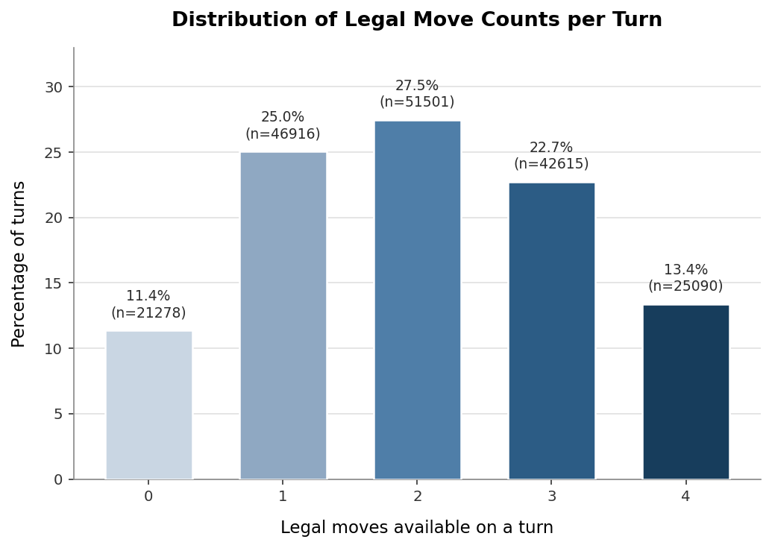
Figure 7: Average Legal Moves per Turn in a 2-Player Match

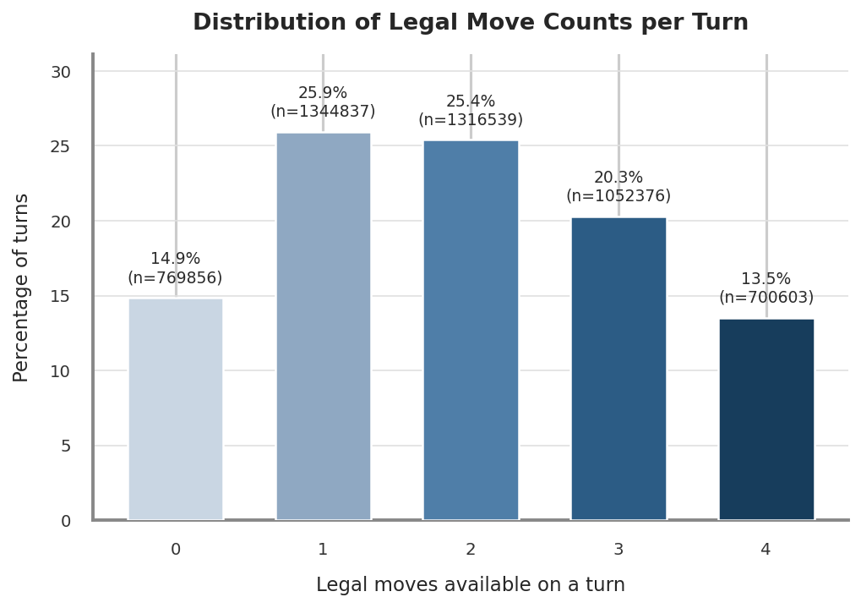
Figure 8: Average Legal Moves per Turn in a 4-Player Match

Analysis of real game positions showed that each position in a two-player game has a mean and median of two legal moves available to choose from at each position, with 36.4% of moves having no choice of action at all. In a four-player game the same quantities are found as being 1.9 legal moves on an average turn and 40.8% of turns having no choice of action. This can be interpreted to show that compared to other games, the ceiling of skill expression in Ludo is quite low.

Game Length Distribution

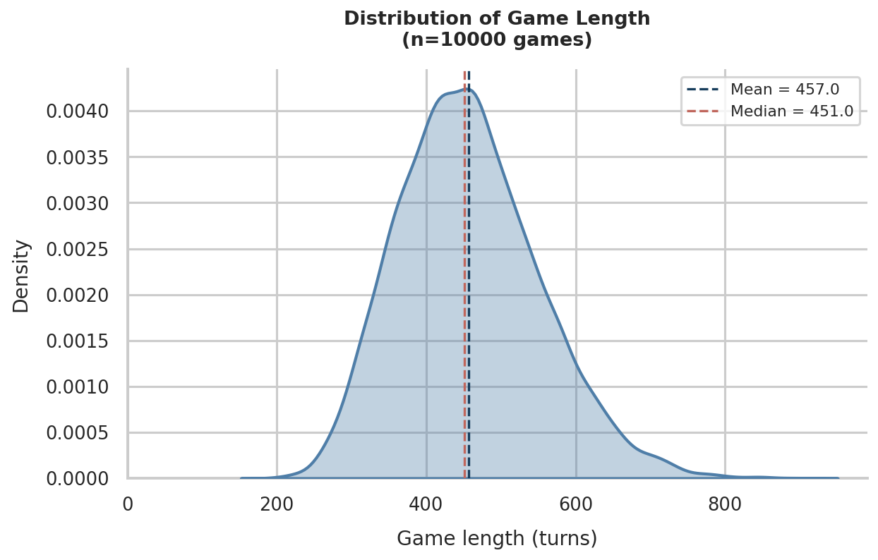
Figure 9: Game Length Distribution Kernel Density Estimate Graph (4 Players)
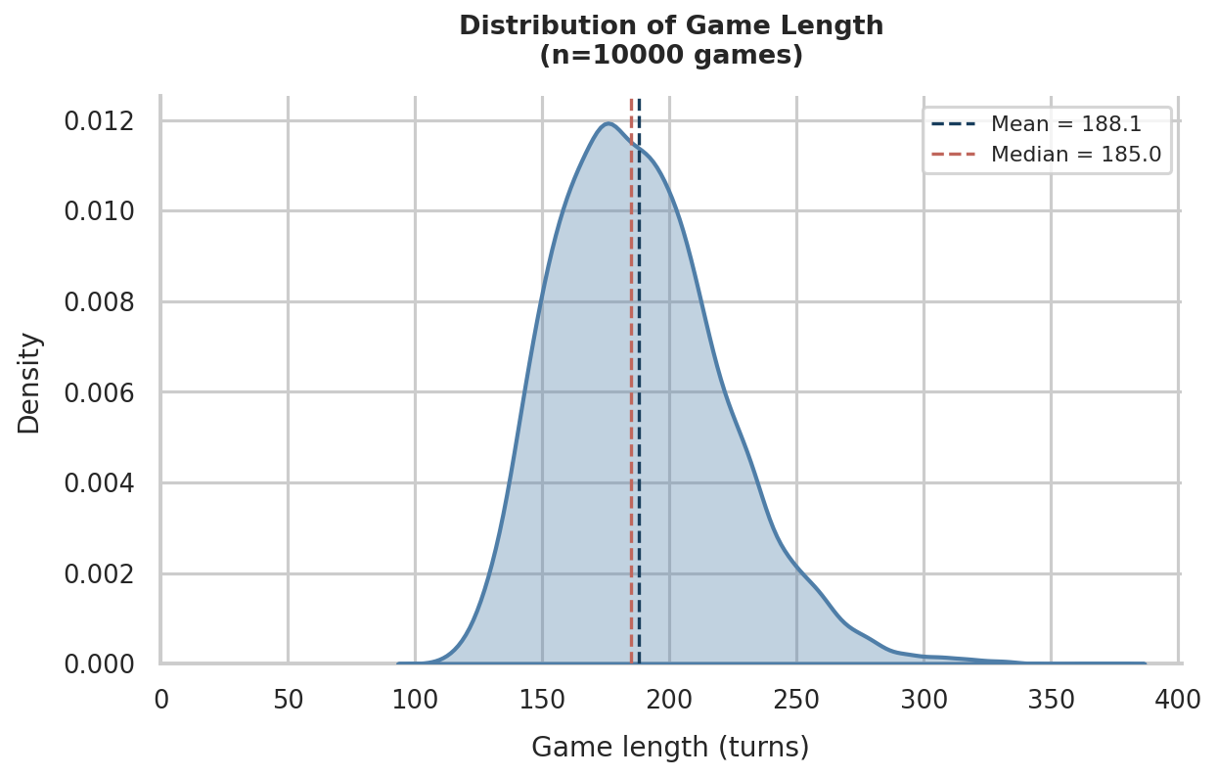
Figure 10: Game Length Distribution Kernel Density Estimate Graph (2 Players)

The game length for a given number of players is fairly consistent, and centres closely round the mean. The average number of turns per player is noticeably higher in a four player game at 114 compared to 94 for a two player game. This is likely due to more pieces on the board leading to more captures over the course of the game.

Number of Move Options by Game Progress
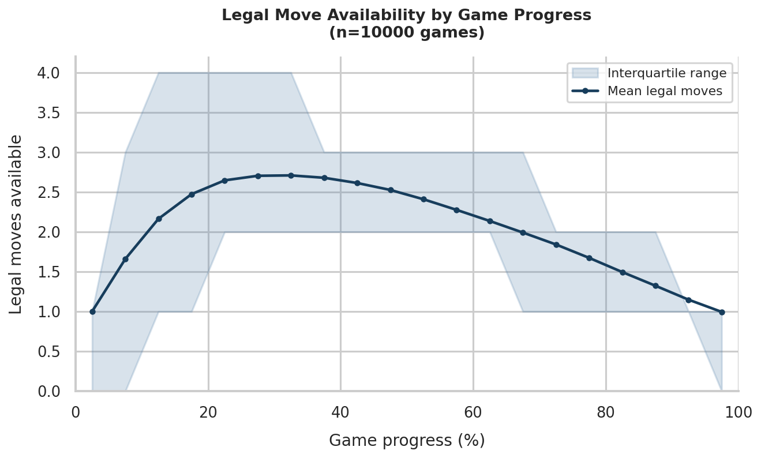
Figure 11: Average Number of Legal Moves by Game Progress - 2 Players
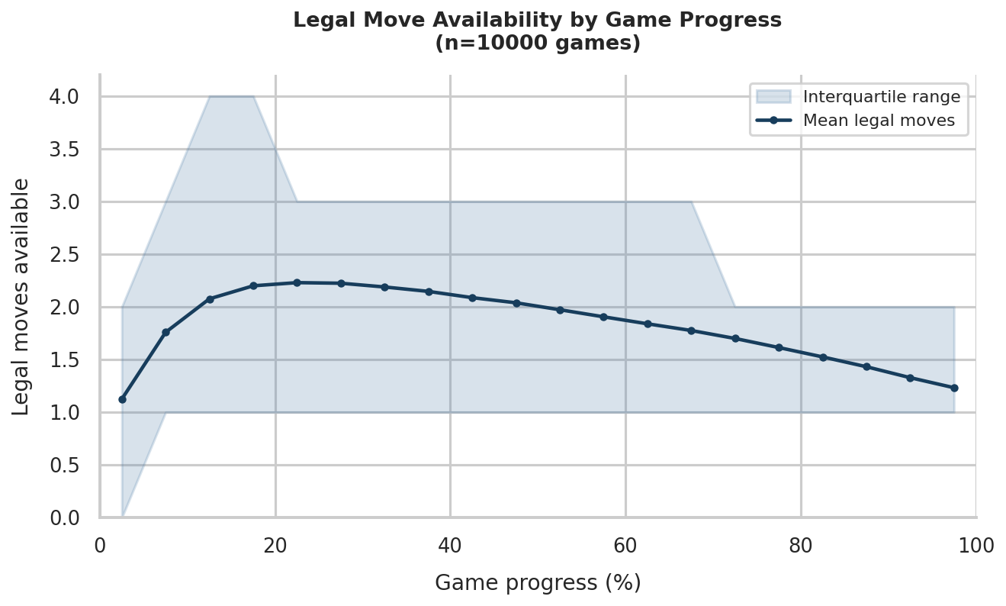
Figure 12: Average Number of Legal Moves by Game Progress - 4 Players
In both two-player and four-player formats the number of legal moves peaks early on between 20 to 30% of the way through. A two-player game has a higher peak in available moves. This would suggest a greater degree of skill expression available in a two-player game; however this would likely be balanced out by the longer game length in a four-player game.

Average Number of Captures Made/Conceded in a Game

Number of Players | Average Captures Made | Average Captures Conceded
2 Players | 2.38 | 2.38
4 Players | 7.90 | 7.90
Figure 13: Average Captures Made/Conceded by Number of Players
The above table shows how many captures are made by and against a player in a match played against identical players on average, assuming all opportunities for capture are taken. The test for this used the Heuristic strategy for all players as it is a close stand in for skilled play and is also guaranteed to take any capture opportunity.

As can be seen in the table, a game with 4 identical players as opposed to 2 has over triple the number of captures made per player. The ramifications of this are that:

- Higher frequency of captures in a four-player match makes it more important to avoid them.
- Making piece activations when they are available becomes more important in four player matches as more pieces will be lost.
- Making captures is no longer a pure gain; if you capture one opponent’s piece, the other opponents benefit from that as much as you do. This contrasts with the zero-sum nature of a two-player game.

Basic Strategies
This section will attempt to recreate and build on the results found by Alvi & Ahmed (2011) and Alhajry et al (2012) which explored playing strategy for Ludo both by simulation and mathematically. The paper describes three basic strategies:

- Defensive, which prioritises moves which escape from an imminent threat.
- Aggressive, which prioritises moves which will make a capture.
- Fast, which prioritises moving the piece furthest ahead on the track.

All of these strategies default to a random move if a move fitting the priority condition is not present. The paper also describes a mixed strategy player which prioritises defensive moves, followed by aggressive moves, followed by fast moves, and defaults to a random move.

As a note, the version of rules that is followed in the paper may not completely align with those being followed in this report, as the paper has not directly specified which ruleset is being followed. However, it is mentioned indirectly in Alhajry et al (2012) which acts as a follow-up to Alvi & Ahmed (2012). There it is mentioned “to have a more realistic assessment of these strategies’ performance, we implemented […] the following game rules.” And among the rules mentioned are that a player needs to roll a 6 to release a piece and a player is granted a bonus roll on a 6. The implication of this statement is that these critical game features are not present in Alvi & Ahmed (2011)

Basic Strategy | Experimental Results | Results From Alvi & Ahmed
Defensive | 37.3% | 99.3%
Aggressive | 35.0% | 99.4%
Fast | 38.2% | 98.7%
Figure 14: Basic Strategies vs 3 Random Opponents (Win Rate %)

There is an enormous difference between the experimental results and those seen in the paper. I believe that the results I have found are far more realistic than in Alvi & Ahmed (2011), as it’s hard to believe that just a single priority condition could allow a near 100% win rate over three random players in a game that relies so much on random chance, especially given that on average a player is choosing between just two available moves.

Further evidence that the figures for win rates against random opponents in this paper are erroneous is that the enhanced basic strategies discussed in Alhajry et al. (2012) have win rates over random opponents as being 61.09% at maximum.

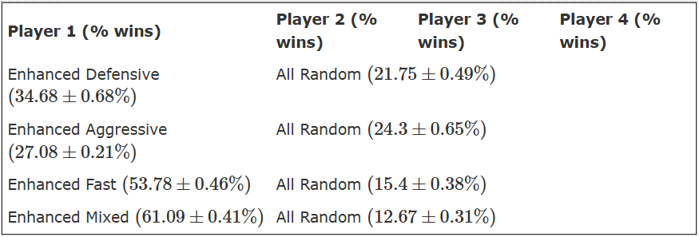
Figure 15: Performance Statistics of Basic Enhanced Strategies (Alhajry et al., 2012)

Basic Strategy | Experimental Results | Results From Alvi & Ahmed
Defensive | 28.9% | 40.3%
Aggressive | 23.5% | 32.5%
Fast | 32.6% | 27.2%
Random | 14.9% | ~0%
Figure 16: Basic Strategies 4-Way Match (Win Rate %)
There is again a discrepancy between results in the four-way match. It makes more logical sense for the Fast strategy to see the best performance as in almost all cases, it has some strategy to employ. However the Defensive and Aggressive strategies will only make a move according to their priority condition in niche circumstances, and for the most part would be making random moves.

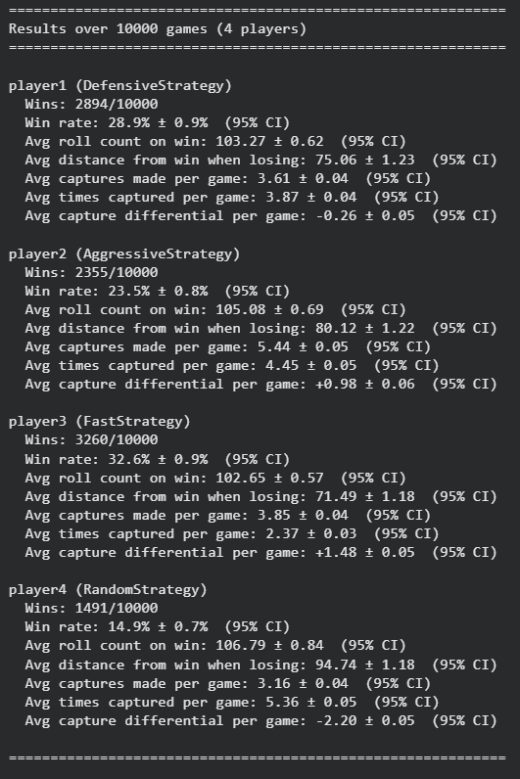
Figure 17: Basic Strategies 4-Way Match - Full Trial Metrics
Referring to Figure 17 which shows the full summary of the 10,000 game four-way match trial, it can be seen that though the Defensive strategy was captured less on average than Aggressive and Random, it was still captured significantly more than Fast, and that Fast actually had the highest ratio of captures made to captures conceded.

A likely explanation for this is that according to the Fast strategy’s policy, it would try to complete a piece’s full circuit round the track before it activated another piece, only doing so if it was the only legal move available. This would naturally lead to less captures being made against it since having only one piece on the track at a time would reduce the probability of being hit compared to having more pieces out.

Mixed Strategy
As mentioned previously, the Mixed strategy player employs a hierarchical policy, prioritising first defensive moves, then aggressive moves, then fast moves.

The Mixed player had a win rate of 39% against random players, which is an increase of approximately 5% over the best basic strategy, however it is a far cry from the 100% win rate shown in the paper.

Strategy | Experimental Results | Results From Alvi & Ahmed
Mixed | 28.4% | 91.4%
Defensive | 22.9% | 3.3%
Aggressive | 20.7% | 2.7%
Fast | 27.9% | 2.6%
Figure 18: Mixed Strategy - 4-Way Match Vs Basic Strategies (Win Rate %)
The Mixed strategy only marginally outperforms the Fast strategy. This is likely due to that in most cases, the Mixed strategy and Fast strategy play according to the exact same policy except in the case of a capture being available or a piece being threatened, but then in those cases, since the Fast strategy was being followed in previous turns, there is likely only a single piece active, meaning the move made is the same.

Enhanced Strategies
The Enhanced strategies mentioned in Alhajry et al (2012) are largely the same, with the difference that they prefer to release a piece upon rolling a 6.

Strategy | Experimental Results | Results From Alhajry et al.
Enhanced Mixed | 48.2% | 48.64%
Enhanced Defensive | 7.0% | 18.24%
Enhanced Aggressive | 4.7% | 12.6%
Enhanced Fast | 40.1% | 20.52%
Figure 19: Enhanced Strategies 4-Way Match (Win Rate %)
From the figure it can be seen that Enhanced Fast benefits much more than the other strategies from the prefer release rule being added to all players. Since Fast always moves the piece furthest ahead instead of making random moves, it never uses its sixes to release a piece unless it has no other valid move, leading to many wasted turns while it waits for a six. This added rule leads to Enhanced Fast wasting fewer moves by having it more effectively utilise its sixes.

However, it may also be that since Enhanced Fast has a much lower rate of being captured compared to Enhanced Aggressive and Defensive, that its higher win rate is due only to it capitalising on Enhanced Mixed getting more captures than previously. This can be tested by replacing the Enhanced Mixed player with an additional Enhanced Fast player.

Strategy | Win Rate (%)
Enhanced Fast x2 | 41.7%
Enhanced Defensive | 9.4%
Enhanced Aggressive | 7.2%
Figure 20: 2 Enhanced Fast, Enhanced Defensive, Enhanced Aggressive (Win Rate %)
Enhanced Fast performs similarly in Figure 19 and 20 so the previous hypothesis can be deemed false.

Heuristic Strategy
This strategy plays according to a policy designed to imitate the way that a human would play, distilled to a set of playing axioms.

Figure 21: HeuristicStrategy Code Snippet

The policy works by checking each piece for 8 different priority conditions and moving the piece that fulfils the highest value priority condition, moving the furthest piece along if there are multiple pieces with the highest priority.

These priority conditions in order of ascending value are:

- Can this piece make a valid move?
- Is the piece in a safe square?
- Can the piece’s circuit be completed?
- Can the piece enter within range to attack an opponent?
- Can the piece reach a safe space with this move?
- Can the piece be activated with this move?
- Can the piece escape from threat of capture with this move?
- Can the piece perform a capture with this move?

Logic Behind Heuristic Ordering

No player would forgo a capture which is available to them, so that must go highest.

Then, if a piece is in a safe square and no strategic objective can be achieved by moving it and there are other legal moves available, then it is better to leave it – so that has a lower priority than a basic legal move.

Preserving progress that has already been made with a piece is more important than getting a new piece out, so escaping is more important than activating.

Getting a piece into a safe space when it is not presently threatened and coming within threat range of an opponent’s piece are both important strategic maneuvers, however their value is contingent and not inherent (on avoiding future capture or achieving a future capture). Therefore their priorities must go behind those already mentioned, with the former having precedence over the latter since it has a more assured benefit and no risk.

A piece that can be completed by entering the end zone with an exact dice roll should have slight precedence over a basic legal move, as not taking the opportunity may later lead to wasted moves trying to get it in at the end of the game, leading to a loss. However, such a piece will always be safe so this type of move should have precedence over nothing else.

Following the above logical process leads to the aforementioned policy. All this to say, no evidentiary material has been prepared to show there is truth to any of the above – it is based purely on a process of logic. But then, that is the best policy to act as a stand-in for a human decision process.

Performance Evaluation

Strategy | Win Rate (%)
Heuristic | 49.4%
Defensive | 16.1%
Aggressive | 11.2%
Fast | 23.5%
Figure 22: Heuristic vs Basic Strategies – 4-Player Match (Win Rate %)

Strategy | Win Rate (%)
Heuristic | 44.4%
Enhanced Defensive | 8.5%
Enhanced Aggressive | 5.1%
Enhanced Fast | 42.0%
Figure 23: Heuristic vs Enhanced Strategies – 4-Player Match (Win Rate %)
The Heuristic strategy outperforms the Mixed strategy against Basic strategies, however it slightly underperforms against the Enhanced Basic strategies compared to Enhanced Mixed. To investigate this further, the follow-up action was to pit Heuristic and Enhanced Mixed against each other directly.
Strategy | Win Rate (%)
Heuristic x2 | 21.7%
Enhanced Mixed x2 | 28.3%
Figure 24: Heuristic vs Enhanced Mixed - 4 Player Match

Strategy | Win Rate (%)
Heuristic | 58.9%
Enhanced Mixed | 41.1%
Figure 25: Heuristic vs Enhanced Mixed - 2 Player Match

Enhanced Mixed is much stronger in a four-player match, whereas Heuristic is stronger in two-player matches. In the four-player match Heuristic gets 1.28 more captures on average, conceding a similar amount to Enhanced Mixed, however this proves ineffectual at allowing it to win more. This links back to what was mentioned in 7.1.5, where it was mentioned that captures in a four-player game are not only of benefit to the capturer, but the other opponents who were not captured benefit in the exact same way.

State Evaluation Strategy

Unlike the previous strategies which all contained policy functions (A function that takes a state and returns the best move), this strategy uses an evaluation function (takes a state and returns a score of how good it is from the perspective of a specific player).

The way that this evaluation function is utilised to inform a playing strategy is:

Figure 26: State Eval Strategy Pseudocode
This is essentially how a search-based strategy would operate in its first step (in other words, a 1-ply search).

Figure 27: Weight Matrices and Player Score Calculation Code Snippet

Figure 28: Evaluation Functions Code Snippet
The code in Figure 27 shows the code used to calculate each player’s individual score, as well as the weight matrices used. To compute a player’s individual score, each piece is checked for the properties of being finished, active, safe or threatened and the corresponding value for each property is added to the player’s total score according to the weight matrix. In addition, a value is added to the score proportional with each piece’s progress, as a piece that has progressed further on the board is worth more.

Additional methods in Figure 28 put these individual scores in the context of the overall game by returning a value that gives an overall score for how advantageous the player’s position is in the game relative to opponents. In other words, this value can be considered to answer the question “what is the chance that I can win from here?”

Two different state evaluation methods are present, with one for four-player games and one for two-player. This is required because the four-player state evaluation must consider that a loss for one player (i.e. a capture) is not just a gain for the playing agent, but that the gain is shared between all players. This is done by applying a softmax function according to the temperature parameter tau over all players' scores rather than just evaluating the difference between player and opponents, so a captured piece's lost value is redistributed across the whole field rather than credited entirely to the capturing agent.

However, this is unnecessary in the two-player game which can be considered as strictly zero-sum, so a simple differencing suffices in this case. The capture_bonus weight is used here to weight each of an opponent’s active pieces differently to the player’s own, or else the value of an activation would have to be equal to the value of a capture, which may not be true.

Tuning of Weights

The weight dictionary ORIGINAL_W represents an initial approximation of what the value of these different properties was. The TWO_W and FOUR_W, however, are tuned weights, worked out using an optimization method called Nelder-Mead. This calculates the optimal weight vector by mapping seven weight vectors as vertices of a shape in a six dimensional space, with a win rate recorded for each vector across many games, and iteratively moving the vertex with the worst win rate in the opposite direction of where it is in relation to the centroid of the shape, thus updating the values of the worst weight vector towards something potentially better. By turns, this moves the whole shape towards the region of optimal weights.

The use of Nelder-Mead optimisation can be considered to be adjacent to reinforcement learning techniques, as in both cases the algorithm improves its performance through performing the task it was made to do.

Inference of Weight Matrices

Weight Name| Matrix Name | ORIGINAL_W | FOUR_W | TWO_W
Finished | 100 | 37.25 | 37.25
Progress | 1 | 3.175 | 2.977
Active | 10 | 30.030 | 27.389
Safe | 6 | 5.712 | 5.330
Threatened | -18 | -15.768 | -11.112
Capture Bonus | -3 | - | -2.028
Tau | - | 47.494 | -

Much can be inferred from the values of the tuned weight matrix as to the differences between two-player and four-player play and the nature of the game overall. For example, in a two-player match, it shows that having a piece be active as opposed to inactive (giving +27.389) is equivalent in value to having an existing piece be 9.2 steps further forward, suggesting that it’s better to use a 6 to activate a piece rather than move a piece (giving +17.86) as it rewards a greater number of points. However, if you moved a piece with a 6 and it threatened an opponent piece it would reward 17.86 in score as well as reducing the opponent’s score by 11.112 (giving a state score of +28.974 compared to previous), making moving a piece as opposed to activating advantageous on average in that situation — unless that move led to you also being threatened by another of the player’s pieces, in which case it would cancel out back to +17.86.

The example given demonstrates how the method of state evaluation across players allows for very straightforward computation to capture complex relationships that would be much more difficult to capture using a policy function.

Comparing the weights between those tuned on two-player and on four-player games, we can see that the weights are generally similar. However, the biggest difference lies between the weights of threatened. These values show that being in a vulnerable position in a four player match is far more detrimental than in a two player match. This lines up with the findings shown in 7.1.5, demonstrating that captures are over three times more frequent in four-player matches.

Comparing Value of Capture Between 2P and 4P
We will compare the difference between the capture of a piece with zero progress with all players starting at an equal footing in the case of both the two-player and four-player state evaluation functions (an impossible scenario since an opponent with zero progress would be safe, and the player would have to move to make a capture, but just for the sake of demonstration).

Using the matrices above we can see that in a two-player match, the opponent losing a piece would result in them losing (active – capture bonus) points which comes out to a state of +25.361 for the player after evaluating the difference between the player’s and opponent’s points, equal to 8.52 steps of progress.

In the four-player version, each player starts with a win probability of 0.25. To work out the new win-probability we subtract (active/tau) from one player’s score giving [0, -0.632, 0, 0] as the new set of scores. Performing e^{x} on all these values and summing them returns 3.53, with the natural logarithm of this value being equal to 1.262. Calculating e^{(0 – 1.262)} gives P(win) for the player which is 0.2832. Following the same set of steps with the weight for one step of progress gives 0.2627, showing that a capture is worth only 2.61 steps of progress in a four-player match.

Performance Evaluation
In order to evaluate the State Evaluation Strategy it will be tested against the strongest two-player opponent and the strongest four-player opponent, being the Heuristic and Enhanced Mixed strategies respectively.

Strategy | Win Rate (%)
State Evaluation | 55.6%
Heuristic | 44.4%
Figure 29: State Evaluation vs Heuristic - 2-Player Match Results

Strategy | Win Rate (%)
State Evaluation x2 | 25.1%
Enhanced Mixed x2 | 25.0%
Figure 30: State Evaluation vs Enhanced Mixed - 4-Player Match Results
State Evaluation achieves a strong advantage over Heuristic in a two-player match, but negligible difference in win-rate in a four-player match against Enhanced Mixed.

A possible explanation for this difference in performance is the “blind spot” between turns. In the two-player match, there is only one action’s worth of difference between the positions that the strategy evaluates versus the input state the strategy next receives. By contrast, there is a difference of three actions between what State Evaluation strategy evaluates and what it next sees in a four-player match. This equates to a difference of 24 potential board states after a single roll versus 13,824 after three. This dilutes the value of evaluating just the immediate move.

Expectimax
This method utilises the expectimax search detailed in 2.2.4.2 combined with the state evaluation function as described in 7.6.

Search Space Complexity
Going back to the State Evaluation Strategy, this method can be considered as searching to a depth of 1, looking only at the directly following position from moves available given the current dice roll. This means that it evaluates up to a maximum of 4 states.

An additional depth of search would entail evaluation of the up to 4 states as mentioned, then for each of these states, the states available to the opponent following any dice roll of 1 to 6. Assuming 4 moves are available from any of these dice rolls gives a maximum of 96 evaluations. Looking even further beyond that to our next move in a two-player match gives 2304 states to search.

Searching each turn past the initial turn multiplies the maximum search space by a factor of 24 (six possible dice rolls times four states). In a four-player match, evaluating each following player and coming back to our next move would require searching a space of up to 1,327,104 positions – this level of search is intractable without a highly optimised and parallelised program.

Performance Evaluation
As this is using the same evaluation as State Evaluation Strategy and going beyond, it should at least match the results of State Evaluation Strategy against Heuristic and Enhanced Mixed and should beat State Evaluation Strategy itself.

Strategy | Win Rate (%)
Expectimax (2-ply) | 52.5%
State Evaluation (1-ply) | 47.5%
Figure 31: Expectimax vs State Evaluation – 2-Player Match Results
Strategy | Win Rate (%)
Expectimax (2-ply) x2 | 25.27%
State Evaluation (1-ply) x2 | 24.64%
Figure 32: Expectimax vs State Evaluation - 4-Player Match Results

Strategy | Win Rate (%)
Expectimax (2-ply) | 59.8%
Heuristic | 40.2%
Figure 33: Expectimax vs Heuristic - 2-Player Match Results
Strategy | Win Rate (%)
Expectimax (2-ply) x2 | 26.75%
Enhanced Mixed x2 | 23.25%
Figure 34: Expectimax vs Enhanced Mixed - 4-Player Match Results
Testing shows the previous hypothesis to be correct; applying expectimax search to the previous evaluation function shows performance improvements against the benchmarks used for State Evaluation strategy, as well as beating State Evaluation itself. However, this is at the cost of an enormous increase in computation time.

Using a two-ply search shows the biggest improvement in the two-player games. This makes sense, as going back to what was mentioned about a “blind spot” in 7.6.4, evaluating and averaging all the possible moves of one player removes any blind spot at all. The four-player matches show less improvement as there are still two players to move who may be able to put the player at a disadvantage, and this would not be accounted for by searching only the next player’s move.

It is possible to extend this to a three-ply search for two-player, however the computation time for three-ply makes it intractable to test a four-player match; The difference between depth 1 and depth 3 search is going from approximately 90 iterations per second to 90 seconds per iteration.

Strategy | Win Rate (%)
Expectimax (3-ply) | 63.5%
Heuristic | 36.5%
Figure 35: 3-Ply Expectimax vs Heuristic - 2-Player Match Results
Adding one layer of depth from 1-ply offered a performance increase of 4.2%, whereas adding a further layer to reach 3-ply added 3.7%. This is evidence of some level of diminishing returns with adding more and more layers of depth, however further evidence would be needed to verify this conclusion which isn’t possible with the current program structure. However, this is still a significant increase in performance and demonstrates the greatest playing strength so far.

Search Depth | Captures Made | Captures Conceded
1 | 2.80 | 1.91
2 | 2.82 | 1.64
3 | 3.252 | 1.743
Figure 36: Captures Made/Conceded versus Heuristic by Depth of Search
Looking at the above table a both interesting and expected relationship can be seen. Going from 1-ply to 2-ply and analysing the opponent’s next move doesn’t meaningfully change the captures made but makes a big difference to the number of captures conceded. This shows that looking at the enemy’s next possible moves across different dice rolls is materially beneficial in evading captures. Likewise, going from 2-ply to 3-ply by going further to the player’s next move after the opponent’s doesn’t reduce the rate of captures conceded (in fact slightly increasing it), but gives a significant increase in captures made.

The fact that the strategy chooses to play more aggressively at higher depth, risking its pieces more in order to make more captures, is also an interesting finding, and links back to the theory of captures having greater value in a two-player game.

TD(λ)

Network Structure and Training Pipeline

This playing strategy is built off the same principles as the TD-Player implemented by Alhajry et al (2011), using an array representation of the board as input for a neural network evaluation function and training the weights of the neural network using TD(λ).

The network’s structure is a feed-forward network, taking as many input arrays as there are players, with two hidden layers of size 64 and 32, and outputting a single value representing the probability of winning given the state.

The neural network was warm-started via a supervised learning task (classification of win/loss from game state) prior to TD(λ) reinforcement learning. This was done using a dataset of positions built from playing games and logging the terminal win/loss status of that game. The validation accuracy achieved by this classifier was around 70%, however this would be skewed by positions near the end of the game being very easy to classify, so the last 20 positions in a game were not included in the dataset.

Following from this, both the two-player and four-player strategies were trained on 300,000 games, playing against a mixture of Heuristic or Enhanced Mixed (for two-player and four-player respectively), State Evaluation and its own frozen copies. This figure is based on the number of training games used for TD-Gammon 1.0 which though much weaker than the final versions, was still very strong, having only a net loss of 13 points across 51 games playing against Grandmasters (Tesauro, 1994). A lambda value of 0.75 was used for training, translating to a 25% signal decay between each step back in an episode.

Performance Evaluation

Strategy | Win Rate (%)
TD(λ) | 50.4%
Heuristic | 49.6%
Figure 37: TD(λ) vs Heuristic - 2-Player Match Results
Strategy | Win Rate (%)
TD(λ) x2 | 24.5%
Enhanced Mixed x2 | 25.5%
Figure 38: TD(λ) vs Enhanced Mixed - 4-Player Match Results
Strategy | Win Rate (%)
TD(λ) | 43.7%
State Evaluation | 56.3%
Figure 39: TD(λ) vs State Evaluation - 2-Player Match Results
Strategy | Win Rate (%)
TD(λ) x2 | 23.9%
State Evaluation x2 | 26.1%
Figure 40: TD(λ) vs State Evaluation - 4-Player Match Results
The TD(λ) player was able to narrowly beat the Heuristic player in a two-player match; however it was narrowly beaten by the baseline of the Enhanced Mixed player in a four-player match. Therefore the findings of Alhajry et al (2012) have not been corroborated, especially given that in the paper the playing algorithm was only shown to have been trained on 82,500 games. And as can be seen, it wasn’t much of a match for the State Evaluation strategy.

A potential reason for this could be that updating weights based on individual wins and losses is too noisy, with luck having too much of a factor at each update.

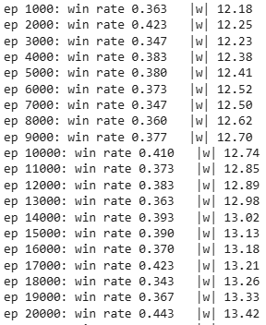
Figure 41: TD Training Snapshot 1
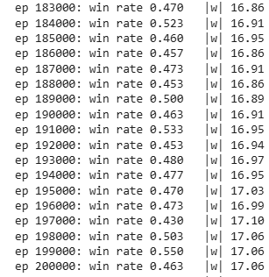
Figure 42: TD Training Snapshot 2
These snapshots sample win-rate over 500 games using a frozen copy of the strategy every 1000 episodes. Looking at the difference in average win-rate between the former and the latter figure it can be seen that the evaluation function has definitely learned gradually, but the learning is noisy and not monotonic.

Contrast this with the Nelder-Mead optimisation that was used to find the optimal weights for feature matrices, which only made judgement and action on a set of weights based on an average of 400 games instead of based on a single game, reducing the noisiness and effects of chance.
Additionally, the NN evaluation function has 2433 weights and biases to optimise whereas the linear evaluation function has just six. This means that the former may be able to encode more information in theory but has no curated features; it must learn everything about the game itself. Whereas the latter has fewer parameters and therefore lesser capacity to capture information, but even from initialisation the evaluation function can implement that activations, progress, captures. etc all have some value quantity in the game.

This richer representation of information leads to the linear evaluation function showing greater success than the NN evaluation function. Perhaps with further training or modification of the NN evaluation function, or combining both full board state representation with handpicked features a greater result could be achieved.

Overall Results and Conclusions

Strategy | Win Rate vs 3 Randoms (%)
Expectimax (2-ply) | 73.3%
State Evaluation | 72.4%
Enhanced Mixed | 66.0%
TD(λ) | 63.8%
Heuristic | 62.3%
Enhanced Fast | 57.4%
Mixed | 39.0%
Fast | 38.2%
Aggressive | 35.0%
Defensive | 37.3%
Enhanced Defensive | 27.3%
Enhanced Aggressive | 25.0%
Random | 25.0%
Figure 43: All Strategies vs 3 Randoms - Win Rate (%)
Strategy | Win Rate vs 1 Random (%)
Expectimax (2-ply) | 93.4%
State Evaluation | 93.1%
Heuristic | 90.8%
TD(λ) | 89.5%
Enhanced Mixed | 85.6%
Enhanced Fast | 72.1%
Enhanced Aggressive | 66.3%
Aggressive | 64.5%
Defensive | 54.5%
Mixed | 52.1%
Fast | 51.6%
Enhanced Defensive | 50.2%
Random | 50.0%
Figure 44: All Strategies vs 1 Random - Win Rate (%)

Strategy | Win Rate vs 3 Enhanced Mixed (%)
Expectimax (2-ply) | 27.8%
State Evaluation | 26.7%
Enhanced Mixed | 25.0%
TD(λ) | 25.0%
Enhanced Fast | 20.6%
Heuristic | 19.5%
Mixed | 13.4%
Fast | 13.1%
Aggressive | 7.5%
Defensive | 4.7%
Random | 3.3%
Enhanced Defensive | 2.9%
Enhanced Aggressive | 1.7%
Figure 45: All Strategies vs 3 Enhanced Mixed - Win Rate (%)

Strategy | Win Rate vs 1 Heuristic (%)
Expectimax (3-ply) | 63.5%
Expectimax (2-ply) | 59.8%
State Evaluation | 55.6%
Heuristic | 50.0%
TD(λ) | 40.4%
Enhanced Mixed | 41.1%
Enhanced Fast | 28.6%
Mixed | 17.2%
Fast | 16.8%
Aggressive | 16.4%
Defensive | 16.2%
Enhanced Defensive | 15.2%
Enhanced Aggressive | 11.8%
Random | 9.6%
Figure 46: All Strategies vs 1 Heuristic - Win Rate (%)
As an initial note, the four-player matches in other sections of this report have been 2v2, but in this section are 1v3. The choice of 2v2 testing was to ensure fair testing between pairs of playing strategies by ensuring the game was symmetric. However for the sake of easier and quicker benchmarking as well as to match with other literature using 1v3 it has been altered for this section.

In all of the final benchmarking tests, the Expectimax strategy followed by the State Evaluation strategy as the 1-ply version have proved to be the strongest playing strategies. The method of using an evaluation function as opposed to a policy function has allowed these strategies to capture greater nuance in their decision-making (7.6.2). Furthermore, the compatibility with search of an evaluation function allows its strength to be amplified limitlessly, notwithstanding computational limits.

Enhanced Defensive and Enhanced Aggressive have in three cases both placed below their non-enhanced counterparts. This is likely because they activate pieces more than their counterparts, but since they default to random play when their strategic condition is not met, they lose those pieces quickly, leading to worse than random results in the case of the benchmark against three Enhanced Mixed players. This same property isn’t seen with Enhanced Fast or Enhanced Mixed since these two both prioritise piece activation as well, but since they have a condition of moving the most advanced piece, they naturally will keep activated pieces at the start leaving them protected until they are necessary to move. The conclusion that can be drawn from this is that releasing pieces when possible is beneficial, but only when those pieces are kept protected and moved judiciously, or else it is detrimental.

Enhanced Mixed places third in the ranking for win rate against three random opponents, and in the benchmark against it is beaten only by 2.8% at maximum. This policy overall can be described as a defensive one, keeping activated pieces protected at the start and having only one piece advance across the track, and moving those pieces from the start prematurely only to take an opportunity to capture. This defensive nature shows why it excels particularly in four-player matches, where the threat landscape is much greater than in a two-player game.

Heuristic holds the equivalent position as Enhanced Mixed in two-player matches. It excelled over Enhanced Mixed in this format likely due to its policy of making not only capturing moves, but moves that can take a piece within range of making a capture. This naturally grants it more capture opportunities which hold greater value in a two-player game, this format having a zero-sum nature (7.1.5). This strategy being drawn from a process of logic, the conclusion that can be drawn from these results is that human playing logic is highly effective for two-player games, but less so for four-player games, that demand safer and more conservative play.

TD(λ) has not fared poorly in these benchmarks; in three of them, it has placed directly between Enhanced Mixed and Heuristic on the leaderboard, showing that it strikes a balance between defensive and offensive play. However, it has shown lesser performance than is suggested by the literature, both in Ludo and in other board games.

Artefact Word Count (not including tables and headings): 4839

APPENDIX B – Project Proposal

Project Proposal Form
Degree Title:  MSc Data Science and Artificial Intelligence | Student’s Name:  Shahir Ali
Supervisor’s Name:
Edward Apeh
Project Title/Area:
Comparing AI Strategies for Playing Ludo

Section 1: Project Overview
1.1 Problem definition - use one sentence to summarise the problem:
The board game Ludo is an unsolved game with very limited research into the domain of its optimal playing strategy, so my project aims to use different machine learning and AI methods to create an AI agent which can play Ludo optimally.

1.2 Project description - briefly explain your project:
My project will include several AI agents designed to play Ludo, such as a heuristic/symbolic AI system, neural networks, linear regressors, and others. These will be evaluated and trained by having them play against each other in order to understand their effectiveness, which will be summarised in a report.

1.3 Background - please provide brief background information, e.g., client, problem domain, and make reference to the literature (minimum 4-5 sources):
Ludo is a classic race game (a game played by moving pieces around a track by way of dice rolls) played on a cross shaped board, with predecessors of the modern game having origins in ancient India (Lal, 1952). The game is played around the world and known by many different names, such as Pachisi in the USA and much of Europe. The research surrounding the game is limited compared to other classic board games. In general, reinforcement learning has been shown to be effective in non-deterministic games, such as in backgammon, where Tesauro (1992) built a system based on temporal difference learning called TD-Gammon which was able to outperform human built expert systems. There has been some research done on Ludo in academic papers, such as by Alvi & Ahmed (2011) who compared different heuristic based players and Alhajry et al (2012) who built further on this study and implemented intelligent players trained using temporal difference and Q learning. However, the amount of research in this game is limited compared to others, providing a valid research gap for my study.
1.4 Research Questions
Can an AI agent using machine learning models outperform an expert system in the game of Ludo?
Which training methods lead to the best performing AI agent for playing Ludo?
Do AI agents trained using genetic algorithms or reinforcement learning lead to better model performance?

1.5 Aims and objectives – what are the aims and objectives of your project? should be specific and measurable:
The aim of my project is to design, implement, and comparatively evaluate a range of artificial intelligence strategies for autonomous decision-making in the board game Ludo, spanning symbolic AI, machine learning, and deep learning approaches, and utilizing multiple model training styles.

My objectives are:
- To review existing literature on AI applications in board games, with particular focus on rule-based systems, reinforcement learning, and machine learning methods applied to stochastic games.
- Develop a functional Ludo environment in which multiple AI agents can be deployed, play against one another, and have their performance recorded systematically.
- Implement multiple agents in the Ludo environment built to play the game autonomously, using different machine learning models and training methods.
- Evaluate and compare all agents against one another using consistent metrics such as win rate, average game length, and performance against a random agent baseline.
- Critically analyse the strengths, limitations, and suitability of each AI paradigm for a stochastic, multiplayer game environment such as Ludo.

Section 2: Artefact
2.1 What is the artefact that you intend to produce?
A Python program containing the Ludo game, with the code for the training and deployment of AI agents within the game, alongside a report evaluating the results of my experimentation.

2.2 How is your artefact actionable (i.e., routes to implementation and exploitation in the technology domain)?
The debate between symbolic and asymbolic AI has existed since the birth of the field. This study would provide further information in relation to that question. Furthermore, if the AI agents show a high performance in the game, it would show that even in a setting where the driving factor of the environment is stochastic (i.e. dice rolls), an AI agent can still learn patterns and relationships which allow it to succeed.

Section 3: Evaluation
3.1 How are you going to evaluate your project artefact?
I will evaluate the results shown by the autonomous players in my study against those in other similar studies, using the same metrics that they have used.

3.2 How does this project relate to your MSc Programme and your degree title outcomes?
This project makes use of the tools and technologies that I have been learning to use in my previous units this year, using AI and data science libraries in the Jupyter environment.
3.3 What are the risks in this project and how are you going to manage them?
Improperly tuned training: The reward parameters in reinforcement learning require careful tuning. An improper reward system could lead to suboptimal performance. To prevent this, I will start by using the reward parameters specified in Alhajry (2012).
Insufficient computing resources: Training deep learners and genetic algorithms can take a lot of time and computing power. If I don’t have enough of either in training it could lead to suboptimal performance. If this happens, I can use cloud computing resources to have access to more powerful GPUs and more RAM, or batch training which trains on a portion of the data at a time instead of all of it.
Improperly implemented environment: If there is any error in the Ludo game environment, then all the results obtained from it will be corrupted. Therefore, I need to test the game well and make sure it is working properly before I begin to implement any AI playing agents.

Section 4: References
4.1 Please provide references if you have used any.
Alhajry, M., Alvi, F. and Ahmed, M., 2012. TD(λ) and Q-learning based Ludo players. 2012 IEEE Conference on Computational Intelligence and Games (CIG) [online], 83–90. Available from: https://ieeexplore.ieee.org/document/6374142.
Alvi, F. and Ahmed, M., 2011. Complexity analysis and playing strategies for Ludo and its variant race games. 2011 IEEE Conference on Computational Intelligence and Games (CIG’11) [online], 141–148. Available from: https://ieeexplore.ieee.org/abstract/document/6031999 [Accessed 13 May 2025].
Lal, B.B. "The Painted Grey Ware culture of the Iron age" (PDF). Silk Road. I: 426–427

Section 5: Academic Practice and Ethics
Please delete as appropriate.
5.1 Have you made yourself familiar with, and understand, the University guidance on referencing and plagiarism? | Yes
5.2 Do you acknowledge that this project proposal is your own work and that it does not contravene any academic offence as specified in the University’s regulations? | Yes

Note: Please complete the research ethics checklist once the proposal has been approved by your supervisor.

Section 6: Proposed Plan (please attach your Gantt chart below)



APPENDIX C – Approved Ethics Checklist

APPENDIX D – Large File Submission Contents
- The code used to produce the artefact in a Jupyter Notebook (.ipynb file type)

